Assignment 2

# Problem 1

This problem required us to implement a MIPS assembly language subroutine called atom that will convert an ASCII uppercase letter to its equivalent in Morse code. The full implementation of this code can be found in the file 1*0387129_ass2_prob1.asm.*

The location of the inputted uppercase letter to be converted to Morse was determined by subtracting 65 from its ASCII equivalent. The result of this would give the location of the Morse equivalent in memory, i.e. “0” would correspond to “A”, and “25” to “Z”.

The data segment before the program is run can be seen in figure 1.

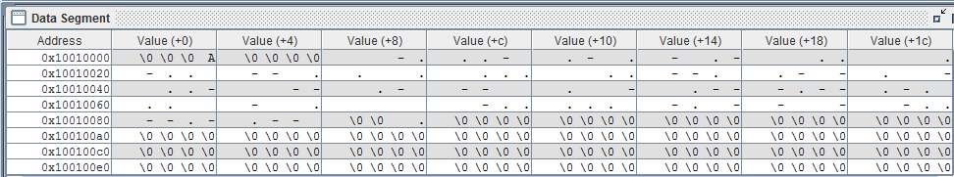

Figure 1: Data segment for problem 1 before the program is ran

Figure 2 shows the data segment after the program is ran



Figure 2: Shows the data segment after the program is ran, the Morse code equivalent for "A" can be seen

# Problem 2

This problem requires us to write a MIPS program called mc that reads in an ASCII string and write out a string with the message encoded in Morse. The solution to this problem is based on the previous problem

The data segment before the program is run can be seen in figure 3.

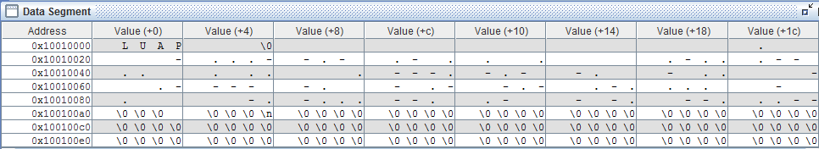

Figure 3: Data segment for problem 2 before the program is ran

Figure 4 shows the data segment after the program is ran



Figure 4: Output of program shows string of characters converted to Morse code

# Problem 3

This problem requires us to write a MIPS assembly language procedure called “mtoa” that will convert the Morse code for a single letter to text. The method I have chosen to solve this problem is to search the data base set up in problem 1.

The data segment before the program is run can be seen in figure 5.

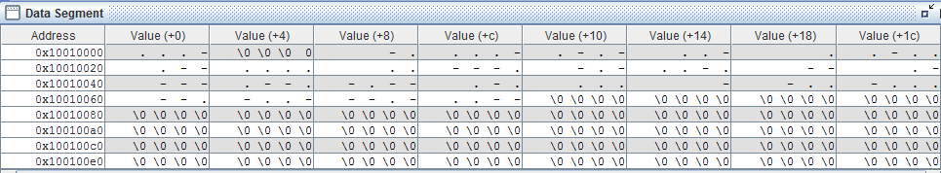

Figure 5: Data segment for problem 1 before the program is ran

Figure 4 shows the data segment after the program is ran







Figure 6: Showing possible outputs for problem 3